**HOSTING A WEBSITE ON AWS EC2 WITH WINDOWS SERVER AND XAMPP**

This project provides a step-by-step guide to hosting a website on AWS EC2 using Windows Server and XAMPP.

Prerequisites -

* AWS Account
* Basic understanding of AWS EC2
* Remote Desktop Connection (RDP) client
* A web project to deploy

Steps to Host the Website is as followed on the next page

Create instance

Go to services search for EC2

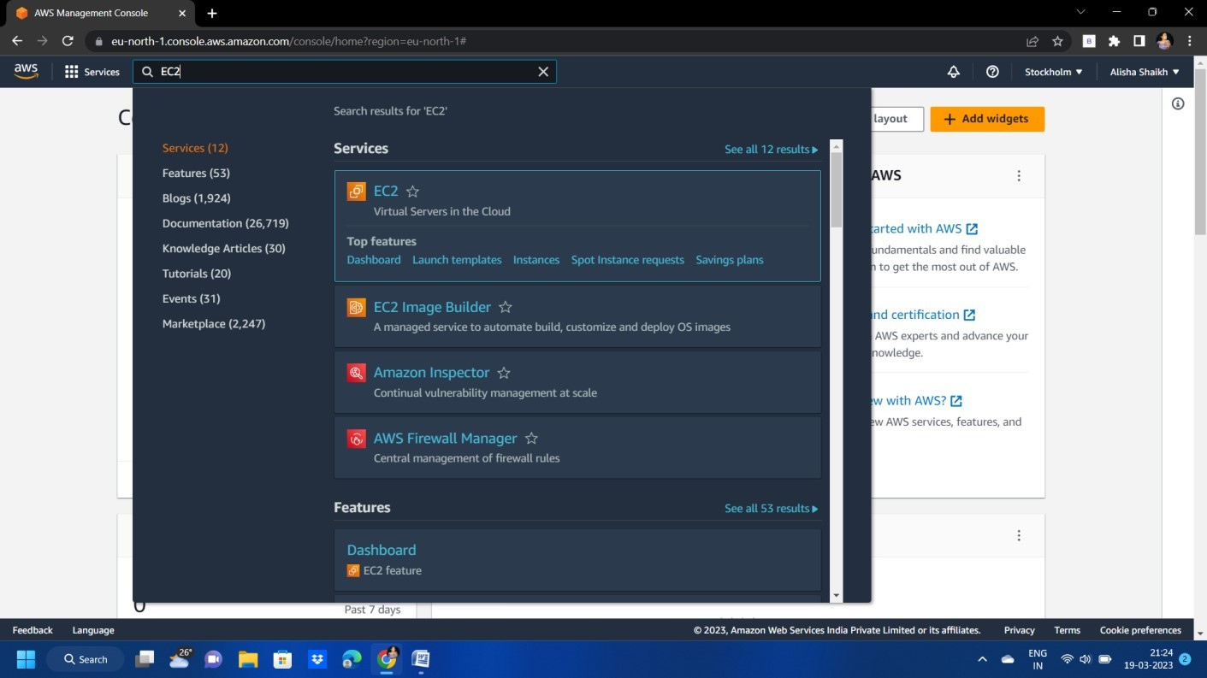

Launch an instance

Give the specific name and tag

After that we have to select Application and os image (Amazon Machine image) Here we select WINDOWS SERVER-2022-ENGLISH-FULL(AMI)

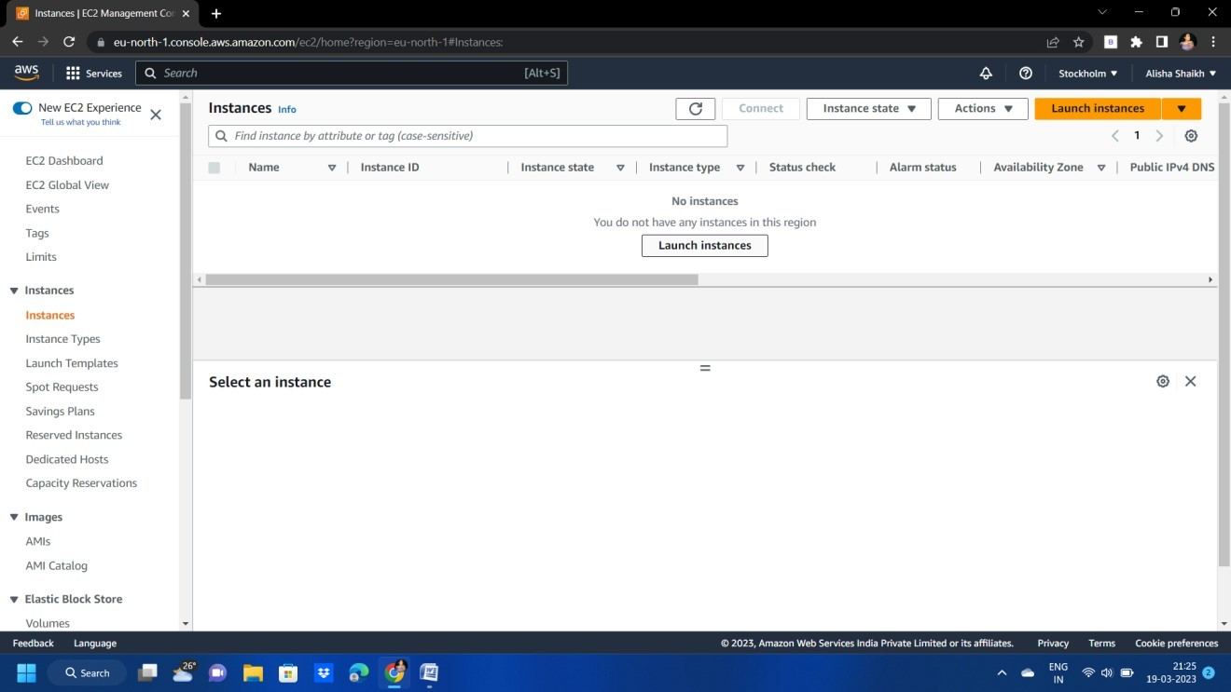

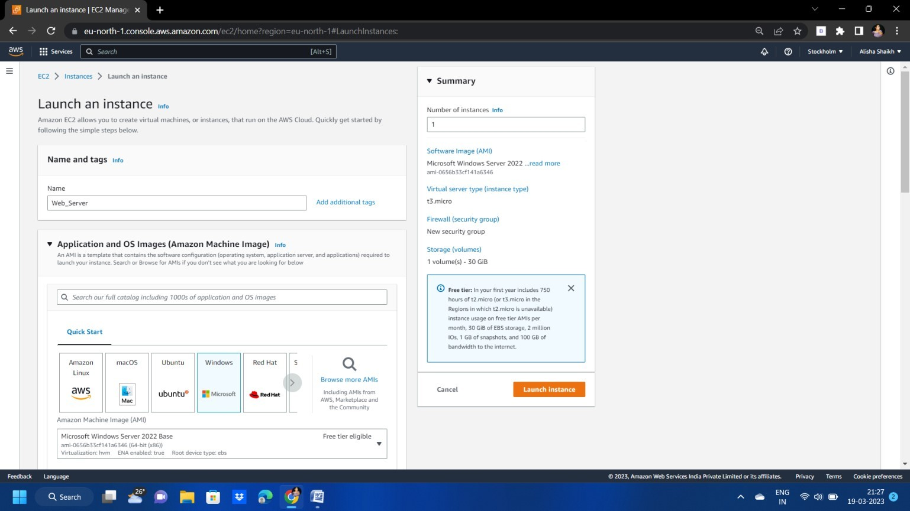

Keep default instance type

We have made key pair to create key pair click on create key pair give the name to key pair And download its and keep its safely

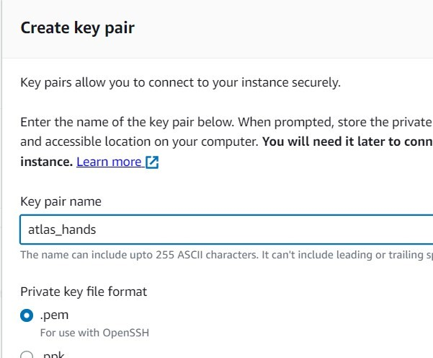

In network setting do some change

To set up end points ,for example when creating a web server select (HTTPS and HTTP)

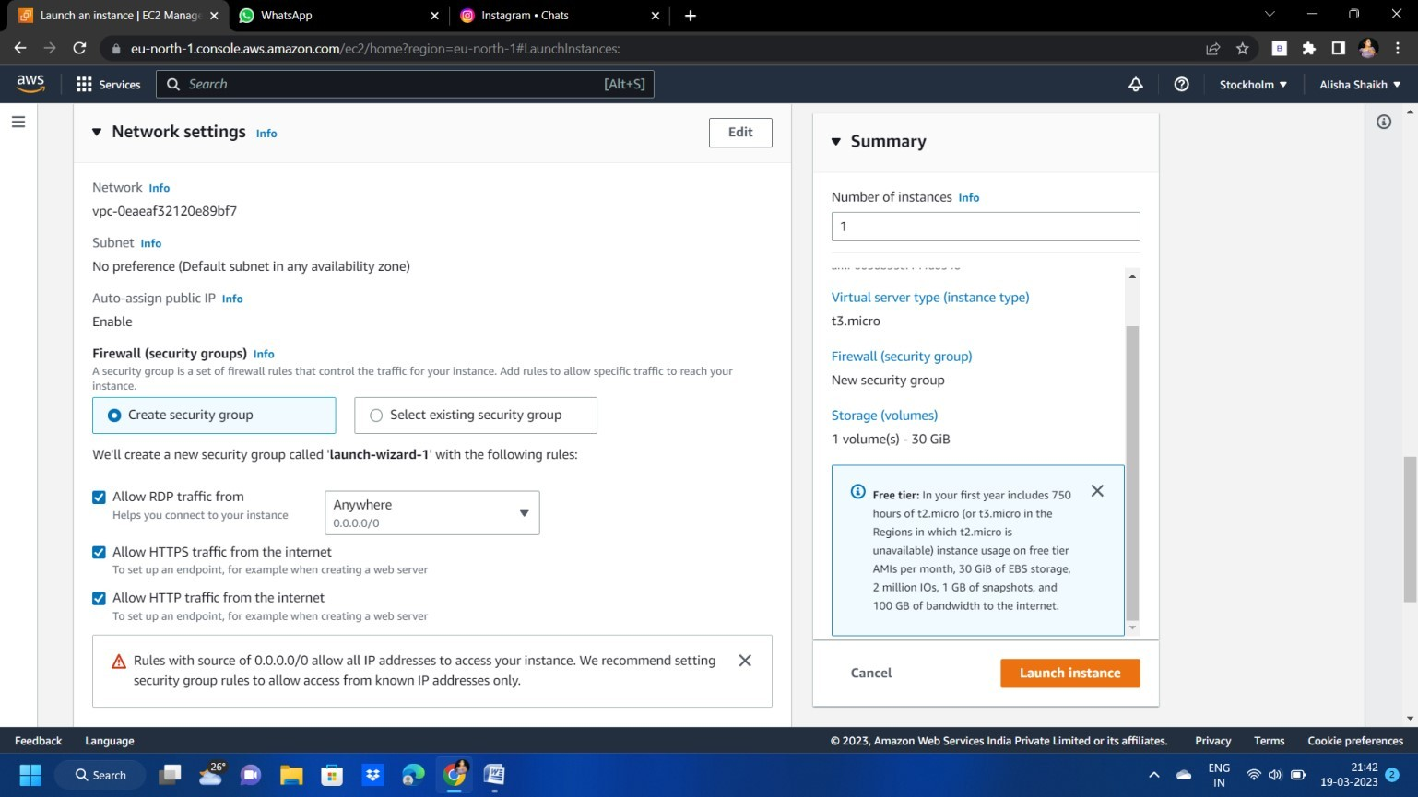

After that in configure storage keep it by default

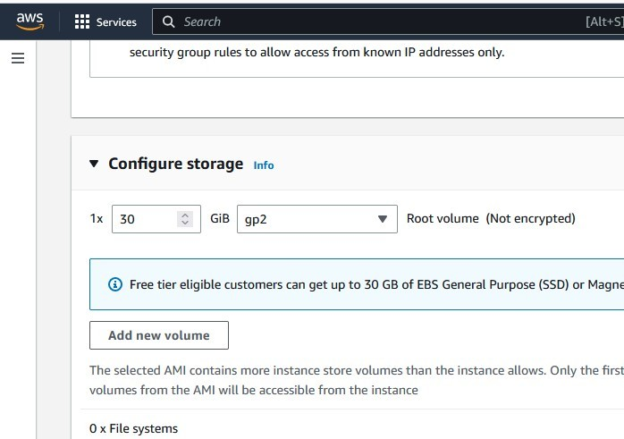

Here the all view of our instance After checking click launch instance

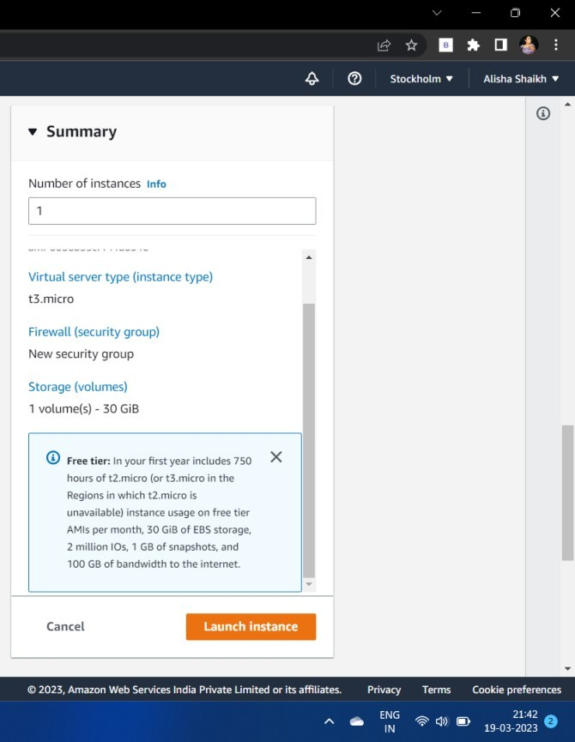

Now u can see instance is running

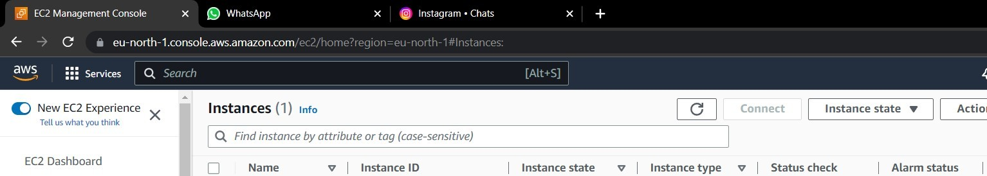

Now we have to connect to instance

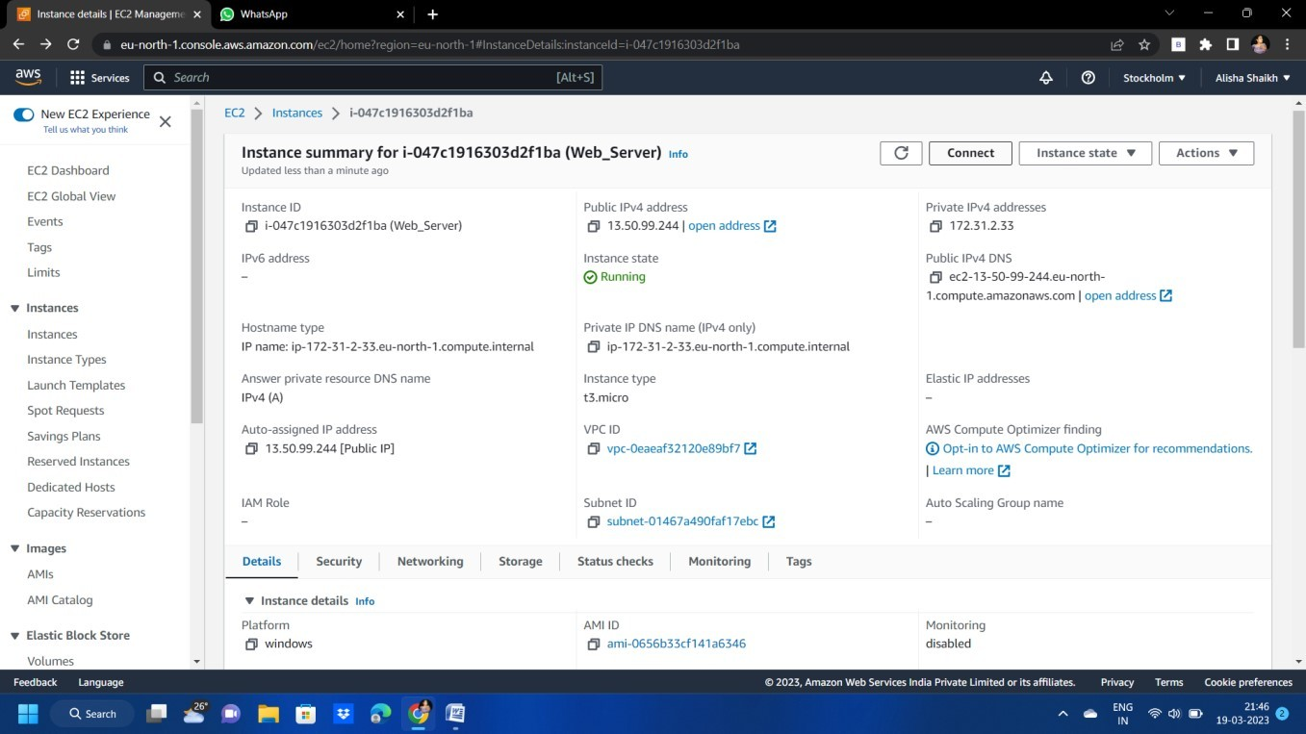

To connect instance, click on RDP client

To get password click on get password and browse the key pair which we have downloaded Then click on password and we will get a password

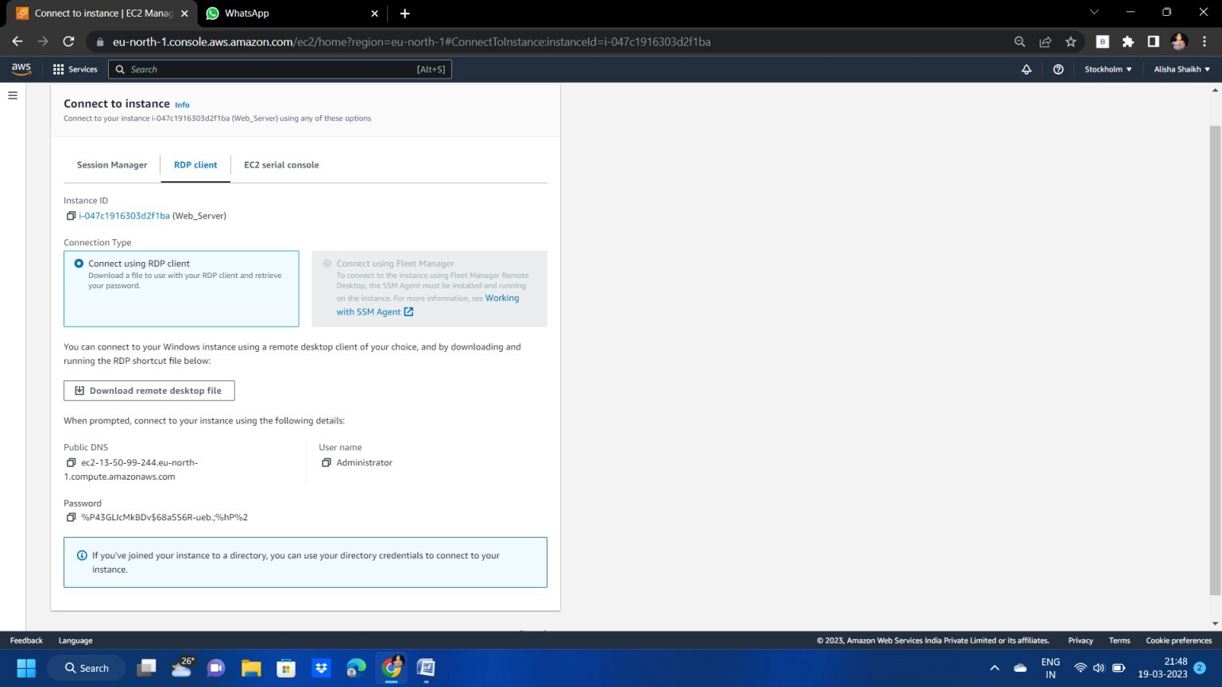

Now to connect the desktop copy the public DNS

Open the remote desktop connection and paste it over there after that copy the user name and password and paste it over there and click on connect

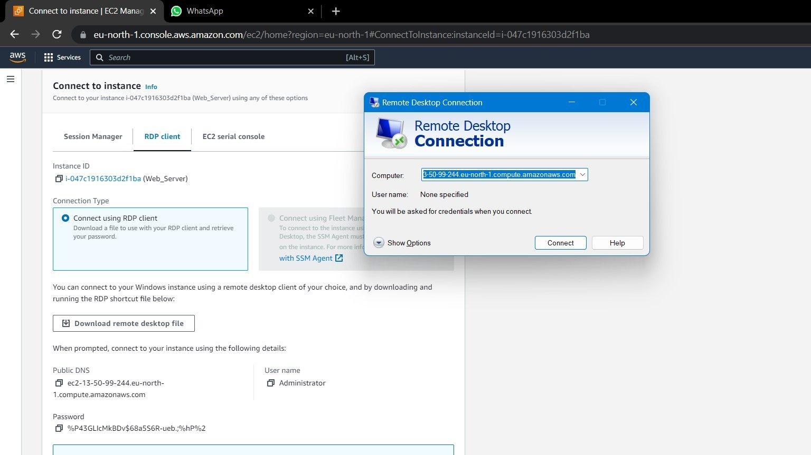

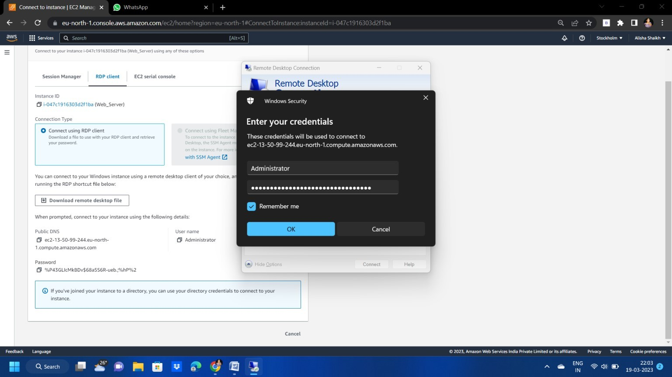

Your remote instance is created

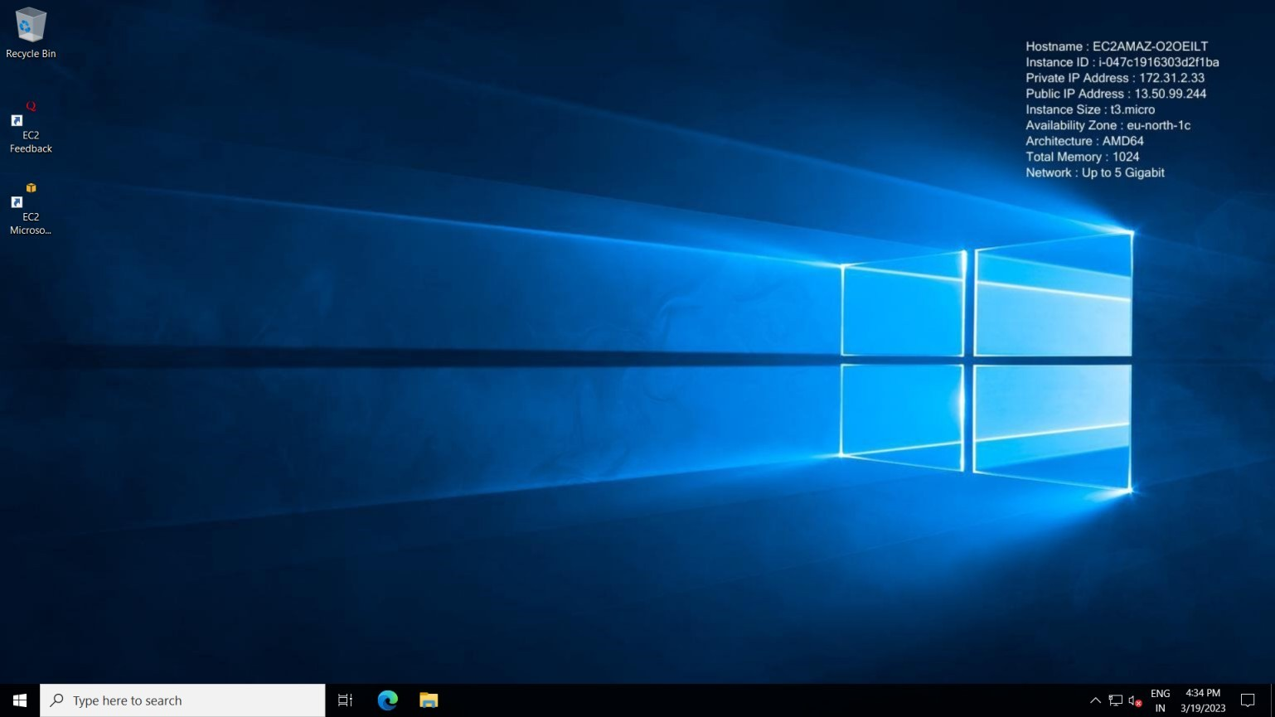

Go to browser and search for xampp and install it

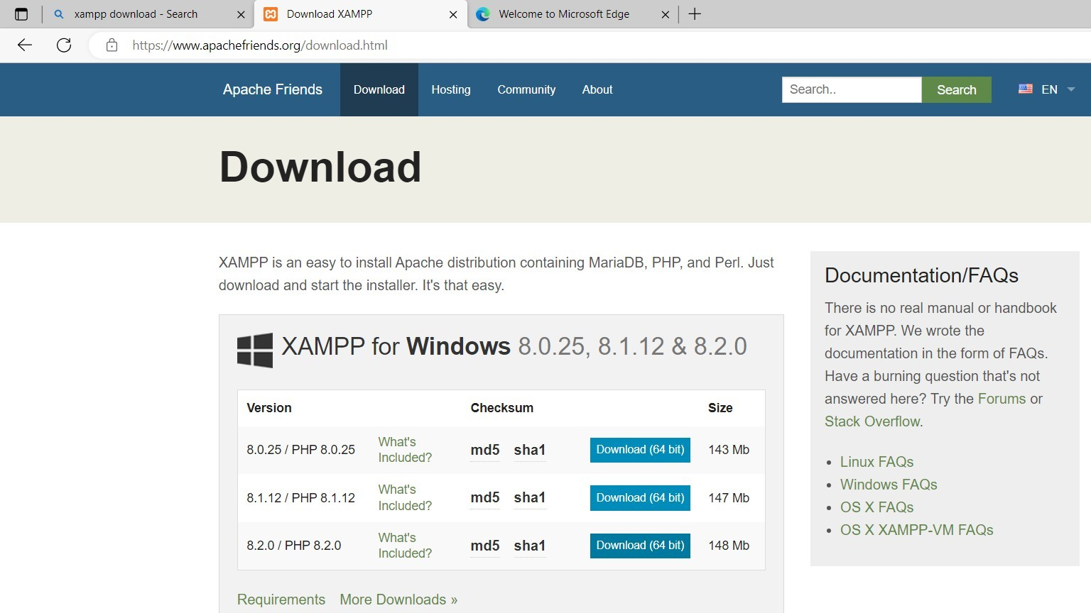

After downloading xampp server copy the project which you want to deploy from system then go to c drive of Remote Server then paste your project folder in xampp -> htdocs

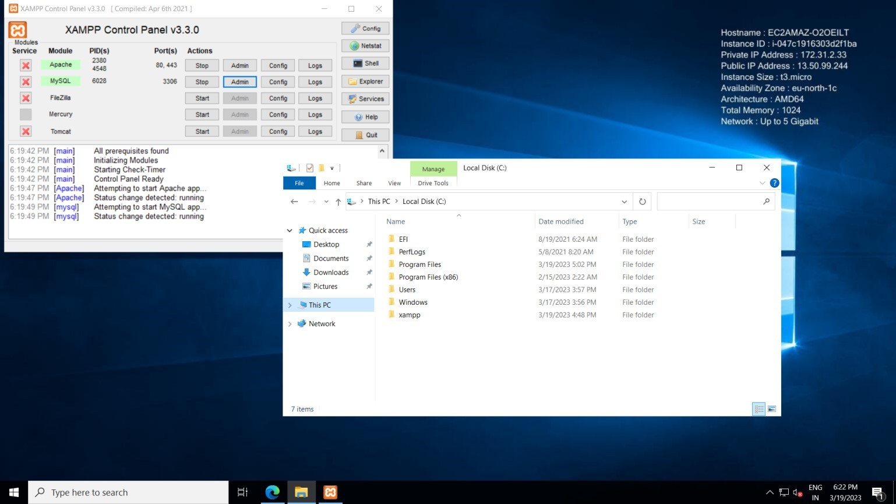

After that start the xampp server and start the Apache and MySQL after that copy your database name and paste it on phpMyAdmin and create database as same as which in you project

Then import the SQL file and click on go Database is loaded here successfully

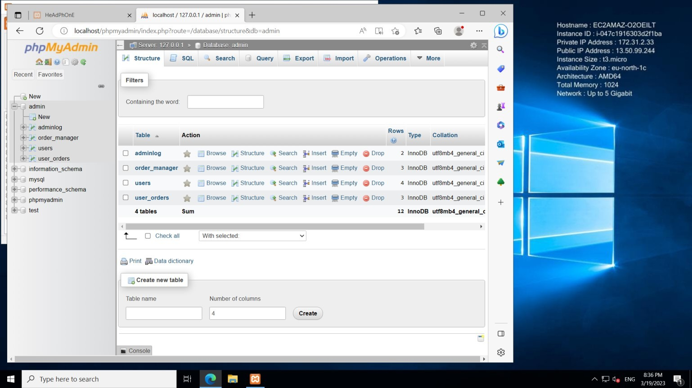

Now , to check our website is visible or not for that click on new tab and search for localhost/headphonesite

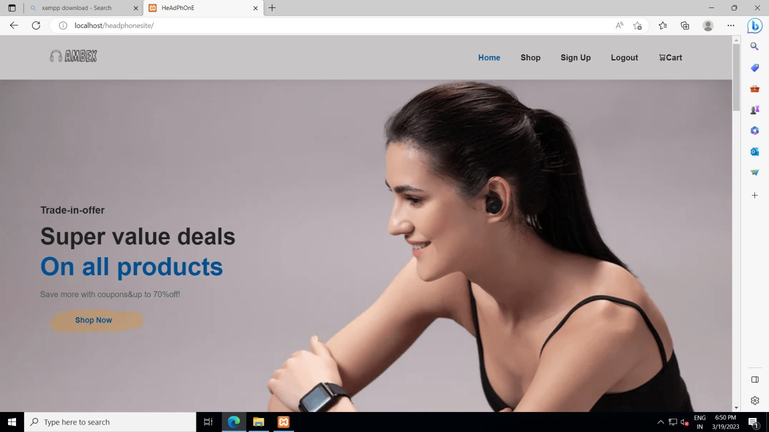

To allow the website on internet there’s a need to do some change in windows security

For that go to windows security then click on firewall & network protection then click on advance setting -

>windows defender firewall properties -> click on domain profile and allow the inbound connection

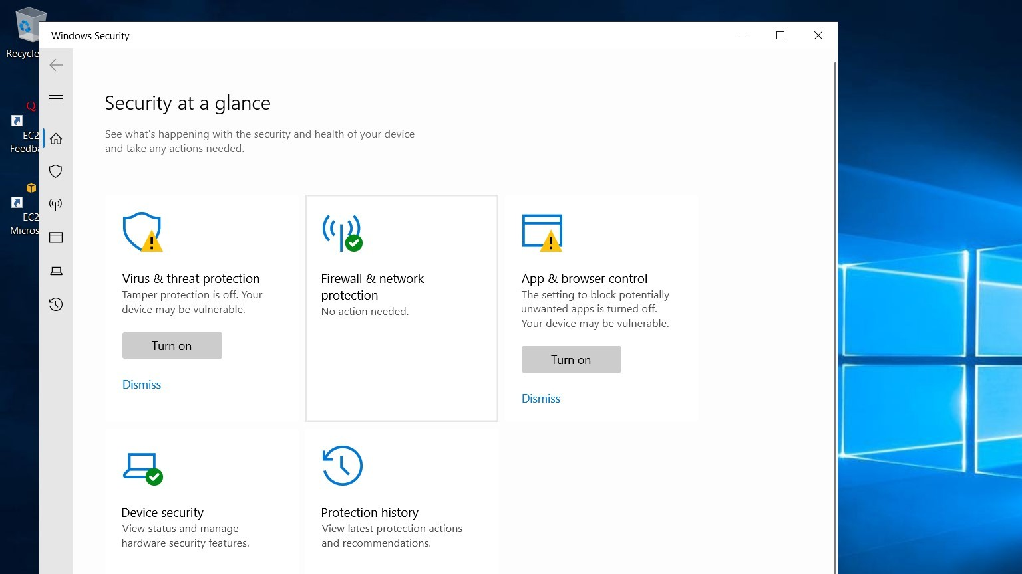

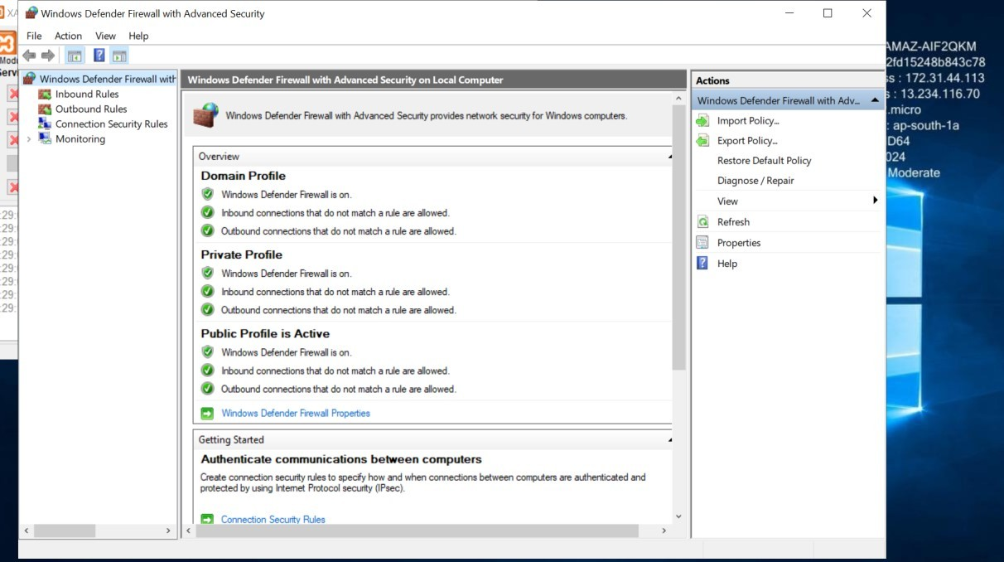

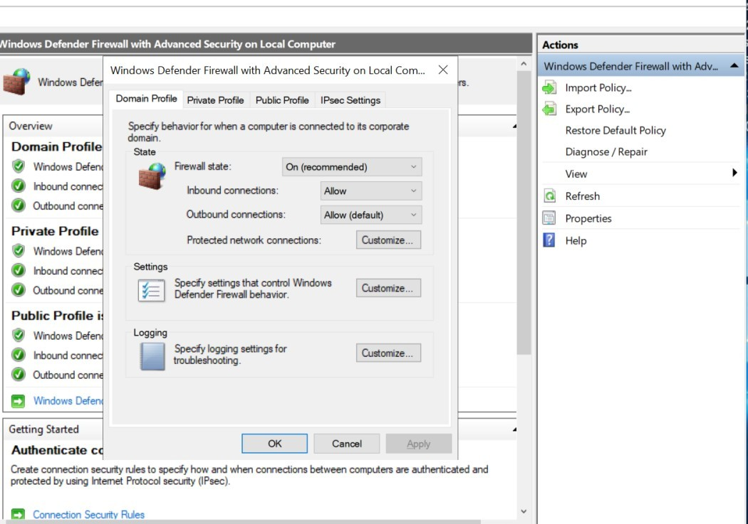

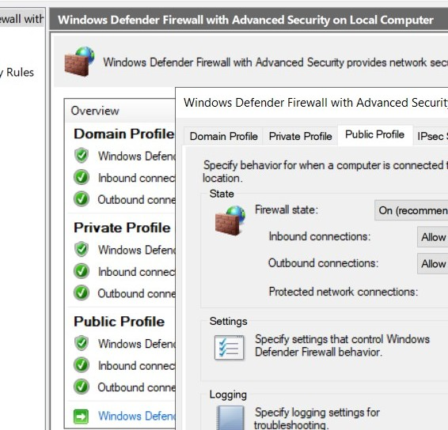Do the same for public and private profile

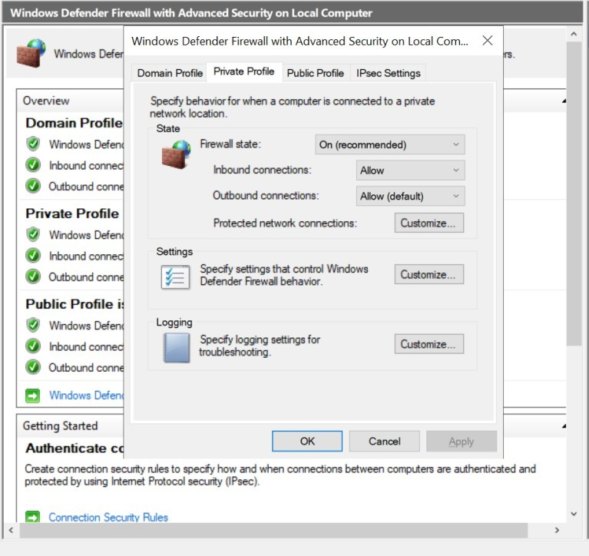

After allowing the inbound connections go to the main system browser then search the IP address which is given in the instance

Then website will be visible as it is deployed successfully

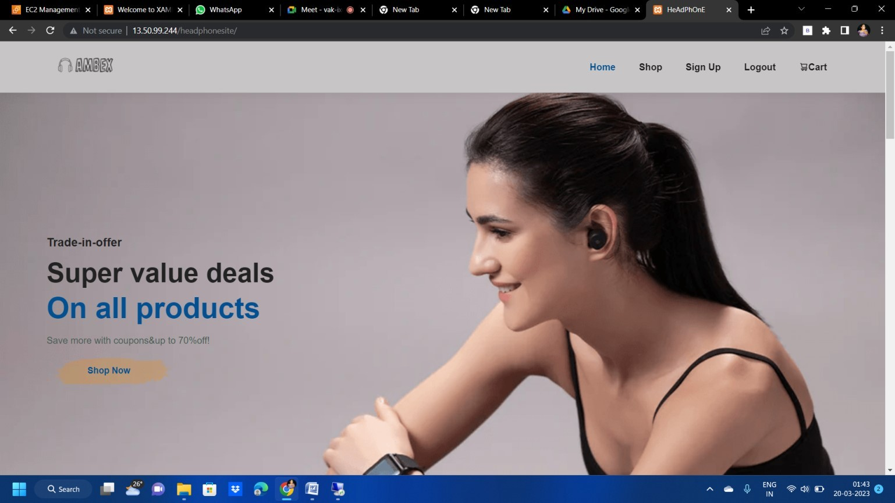

To stop instance

For that go to EC2 dashboard you will see the instance which is created then select the instance which you want to stop then go to instance state and click on stop instance

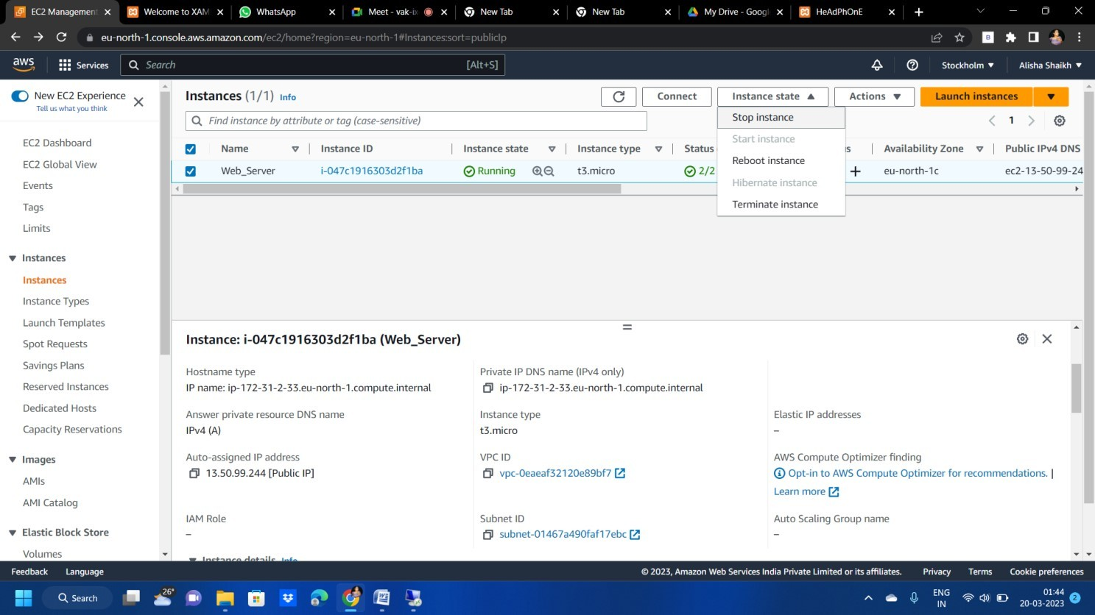

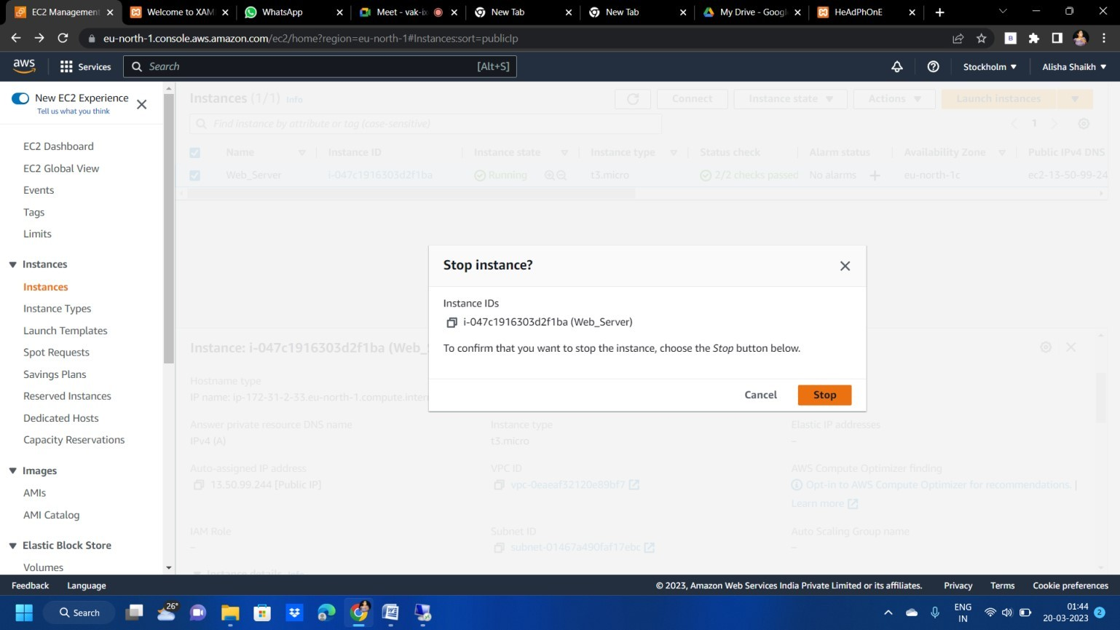

To terminate the instance select the instance and click on instance state and click on terminate instance

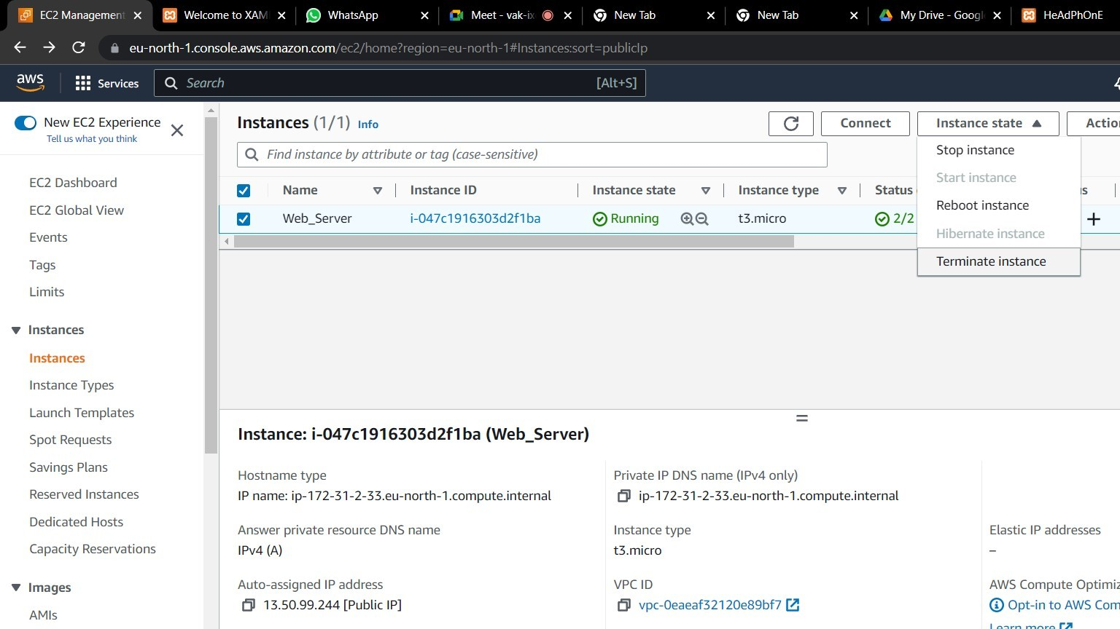

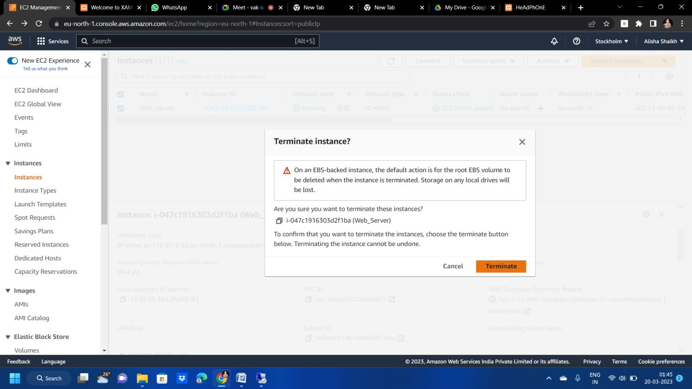

To start instance

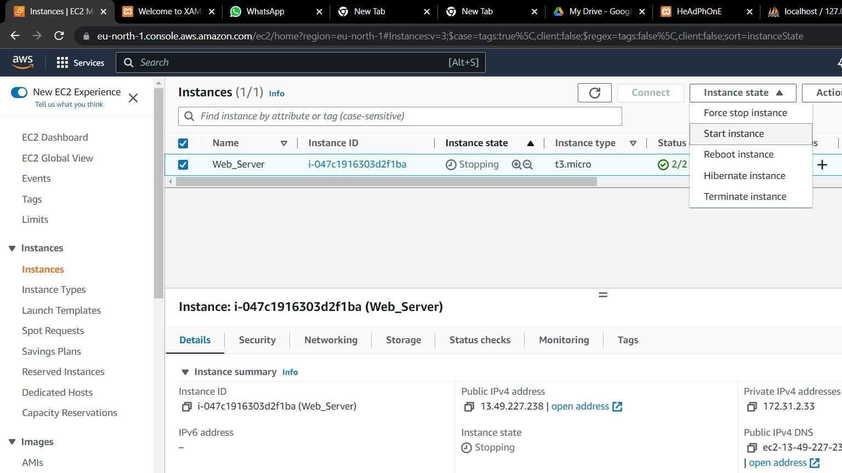

Conclusion

By following these steps, you can successfully host your website on an AWS EC2 instance using Windows Server and XAMPP. This setup allows you to deploy and manage your web applications efficiently.